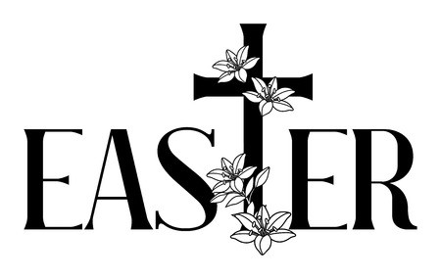

Dear all

The Lord is risen! He is risen indeed!
Happy Easter to everyone. Although we cannot be together in person, God’s Spirit unites us as we share in this most important of days in the Christian calendar.

The Assembly Faith and Order committee have suggested that in these exceptional circumstances we are indeed able to share in communion. If you have some juice (or even water) and a piece of bread, you will be able to join in towards the end of today’s service.

Before we begin our worship, we have a few notices to share with you!
Last week some of you would’ve watched the Tenebrae service on my YouTube channel. We have recorded the Easter Sunday worship as well, accessible by clicking on the link below:
https://www.youtube.com/playlist?list=PLdEyI1GJyjHOF7wG9_JkCU2U3Ex2B__b0

On the top left hand side of the page you will see a picture of me standing behind the lectern with the words “PLAY ALL” on the picture. Click on “PLAY ALL”, and the entire service will proceed. There might be slight pauses between each clip (there are 8 in all), but just leave it and let it keep playing. To make the video FULL SCREEN click on the little broken square icon on the bottom right hand corner of the picture.

The children’s story is available on the clip below:
https://youtu.be/HL8R158Ujp4

Happy birthday to Kathryn Walker (Friday 10 April) and Ella Clearly (today).

